Name: ________________________

SECTION 2 (P. 6 TO 10)
Amount of money raised
City where he raises the money
Problems Terry develops (2)
Solution Doug proposes
Terry’s answer to the proposal
The person who joins Terry and Doug
Problem they have in Québec
The person he meets in Montreal
Message the person sends to Canadian
Amount of money raised
in Ontario
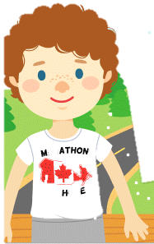

SIGNATURE OF A PARENT: _____________________________
TERRY FOX, A CANADIAN HERO

