

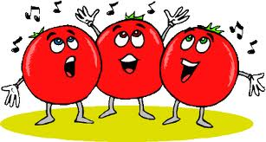

Read the descriptions. Write the name of the foods and match them with the pictures.

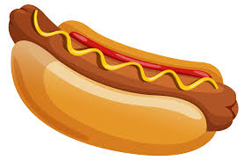

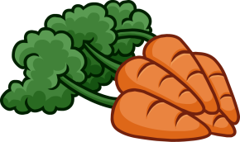

2. I’m yellow and people like me on their pizza.

___________________________

1. You need me to make a sandwich or toast.

___________________________

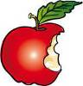

[](http://schools-demo.clipart.com/search/close-up?oid=3869737&q=coffee&s=61&a=c&cid=&fic=0&k_mode=all&k_exc=&q_jpeg=1&q_gif=1&q_color=1&q_bw=1&q_eps=1&q_wmf=1&q_psd=1&q_png=1&date=&pubid=&isadv=1)

4. We are made from potatoes and taste great with ketchup. ­­­­­­­­­­­­­____________

3. We are a small round red fruit. We grow on trees.

___________________________

[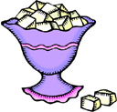](http://schools-demo.clipart.com/search/close-up?oid=3815951&q=sugar&s=61&a=c&cid=&fic=0&k_mode=all&k_exc=&q_jpeg=1&q_gif=1&q_color=1&q_bw=1&q_eps=1&q_wmf=1&q_psd=1&q_png=1&date=&pubid=&isadv=1)

6. We are a very small round green vegetable.

__________________________

5. Eat us fried, boiled or scrambled.

___________________________



8. Children like me with their cereals. Cats just love me. _______________________

7. I’m white and I make your coffee sweet.

___________________________



10. I’m a black hot drink.

___________________________

9. I’m a popular fast food with a sausage in the middle. ___________________

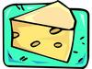

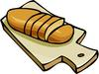[](http://schools-demo.clipart.com/search/close-up?oid=3869737&q=coffee&s=61&a=c&cid=&fic=0&k_mode=all&k_exc=&q_jpeg=1&q_gif=1&q_color=1&q_bw=1&q_eps=1&q_wmf=1&q_psd=1&q_png=1&date=&pubid=&isadv=1)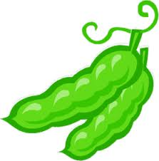

16. I’m cold and sweet. I am especially eaten in summer.

___________________________

15. I’m yellow and sweet. People sometimes put me in their tea. _________________

14. We are a small fruit and can be used to make wine.

___________________________

13. I’m a long yellow fruit.

___________________________

11. I’m a delicious fried, grilled or roasted meat.

___________________________

12. Rabbits just love this vegetable.

___________________________



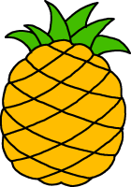

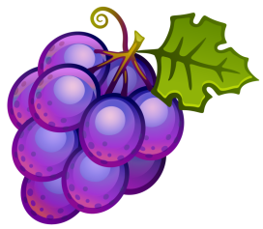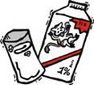

18. I’m a juicy tropical fruit. I have sweet yellow flesh. ___________________________

17. I am a round fruit. I am usually green or red.

___________________________

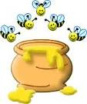





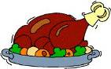





Read the descriptions. Write the name of the foods and match them with the pictures.





2. I’m yellow and people like me on their pizza.

___________________________

1. You need me to make a sandwich or toast.

___________________________



[](http://schools-demo.clipart.com/search/close-up?oid=3869737&q=coffee&s=61&a=c&cid=&fic=0&k_mode=all&k_exc=&q_jpeg=1&q_gif=1&q_color=1&q_bw=1&q_eps=1&q_wmf=1&q_psd=1&q_png=1&date=&pubid=&isadv=1)

4. We are made from potatoes and taste great with ketchup. ____________

3. We are a small round red fruit. We grow on trees.

___________________________

[](http://schools-demo.clipart.com/search/close-up?oid=3815951&q=sugar&s=61&a=c&cid=&fic=0&k_mode=all&k_exc=&q_jpeg=1&q_gif=1&q_color=1&q_bw=1&q_eps=1&q_wmf=1&q_psd=1&q_png=1&date=&pubid=&isadv=1)

6. We are a very small round green vegetable.

__________________________

5. Eat us fried, boiled or scrambled.

___________________________



8. Children like me with their cereals. Cats just love me. _______________________

7. I’m white and I make your coffee sweet.

___________________________



10. I’m a black hot drink.

___________________________

9. I’m a popular fast food with a sausage in the middle. ___________________



[](http://schools-demo.clipart.com/search/close-up?oid=3869737&q=coffee&s=61&a=c&cid=&fic=0&k_mode=all&k_exc=&q_jpeg=1&q_gif=1&q_color=1&q_bw=1&q_eps=1&q_wmf=1&q_psd=1&q_png=1&date=&pubid=&isadv=1)

16. I’m cold and sweet. I am especially eaten in summer.

___________________________

15. I’m yellow and sweet. People sometimes put me in their tea. _________________

14. We are a small fruit and can be used to make wine.

___________________________

13. I’m a long yellow fruit.

___________________________

11. I’m a delicious fried, grilled or roasted meat.

___________________________

12. Rabbits just love this vegetable.

___________________________





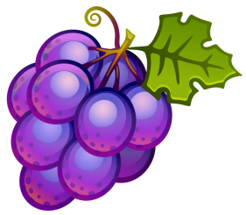

18. I’m a juicy tropical fruit. I have sweet yellow flesh. ___________________________

17. I am a round fruit. I am usually green or red.

___________________________













Read the descriptions. Write the name of the foods and match them with the pictures.



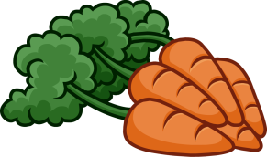

**2. CHEESE**

**1. BREAD**



[](http://schools-demo.clipart.com/search/close-up?oid=3869737&q=coffee&s=61&a=c&cid=&fic=0&k_mode=all&k_exc=&q_jpeg=1&q_gif=1&q_color=1&q_bw=1&q_eps=1&q_wmf=1&q_psd=1&q_png=1&date=&pubid=&isadv=1)

**4. CHIPS**

**3. CHERRIES**

[](http://schools-demo.clipart.com/search/close-up?oid=3815951&q=sugar&s=61&a=c&cid=&fic=0&k_mode=all&k_exc=&q_jpeg=1&q_gif=1&q_color=1&q_bw=1&q_eps=1&q_wmf=1&q_psd=1&q_png=1&date=&pubid=&isadv=1)

**6. PEAS**

**5. EGGS**



**8. MILK**

**7. SUGAR**



**10. COFFEE**

**9. HOTDOG**



[](http://schools-demo.clipart.com/search/close-up?oid=3869737&q=coffee&s=61&a=c&cid=&fic=0&k_mode=all&k_exc=&q_jpeg=1&q_gif=1&q_color=1&q_bw=1&q_eps=1&q_wmf=1&q_psd=1&q_png=1&date=&pubid=&isadv=1)

**16. ICE-CREAM**

**15. HONEY**

**14. GRAPES**

**13. BANANA**

**11. CHICKEN**

**12. CARROTS**





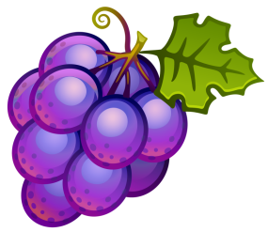

**18. PINEAPPLE**

**17. APPLE**







