At the Amusement Park
Pictionary
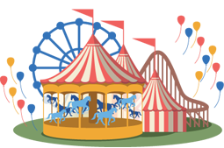  Amusement Park | 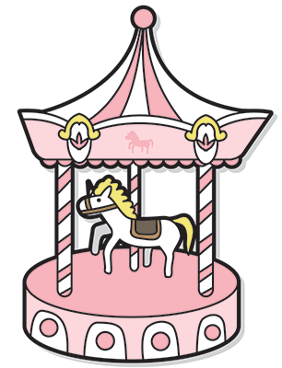  Merry-go-round
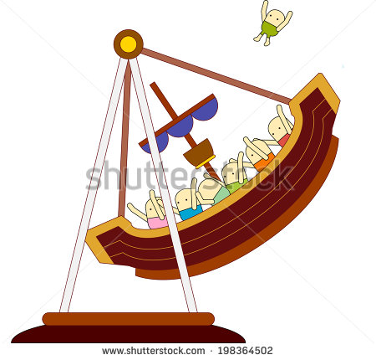  Pirate Ship | 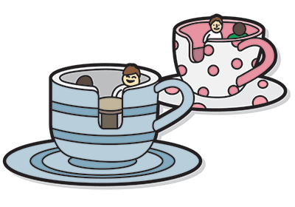  Teacup Ride
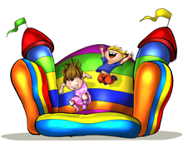  Jumping Castle | 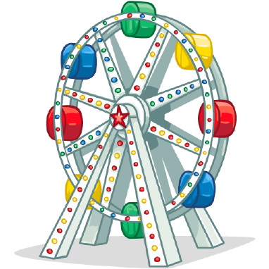  Ferris Wheel
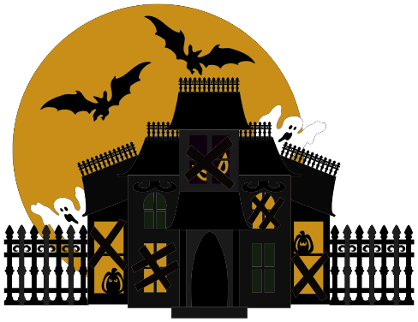  Haunted House | 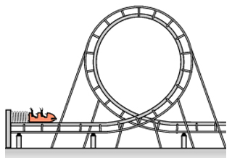  Roller Coaster
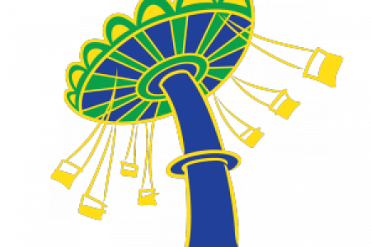  Chair swings | 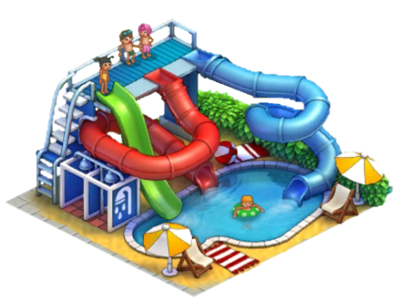  Water Park
A Trip to Knot’s Berry Farm
Bob is telling a story about his weekend.
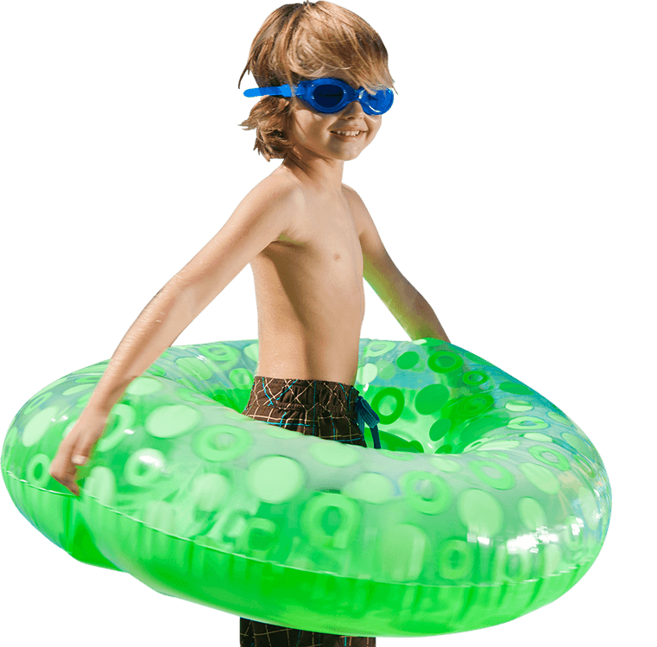
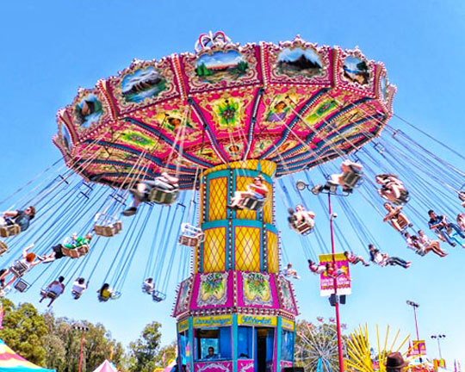
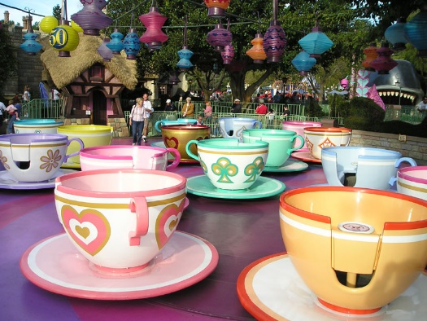
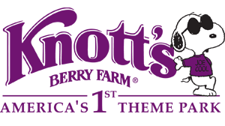
Last weekend, I went to Knot’s Berry Farm. It is a famous amusement park in California. I went there with Peter, Jane and Sue. We took many rides in the park. My favorite ride was the Teacup Ride. Peter liked the Ferris Wheel. Jane and Sue loved to ride the Pirate Ship. We didn’t like the Haunted House the most because it is too scary for us. We played the jumping castle together but we forgot to ride the roller coaster. I didn’t ride the chair swings but all of my friends did. I went to the water park while they were having a good time on the chair swings. I promise myself to ride the chair swings next time. However, it was a great fun for all of us.

Match the words with the pictures.
Ferris Wheel Amusement Park Jumping Castle
Pirate Ship Chair Swings Water Park
Roller Coaster Merry-go-round Teacup ride

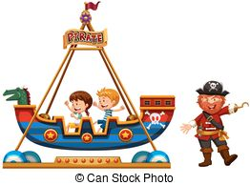  1. | 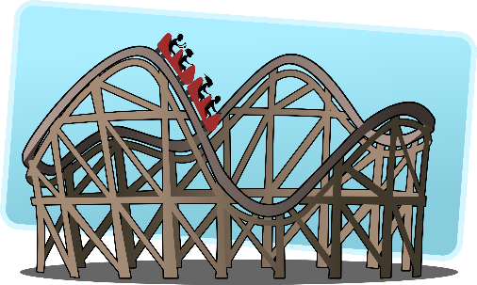  2. | 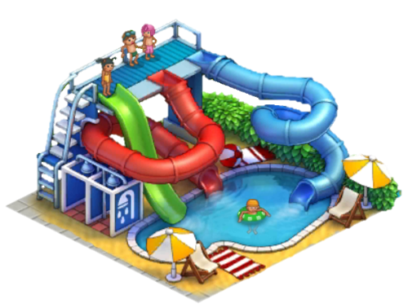  3.
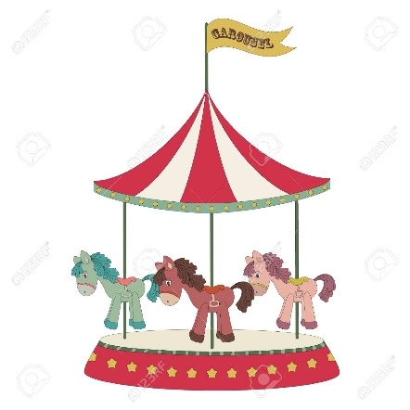  4. | 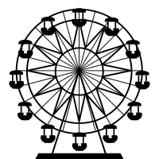  5. | 6.
7. | 8. | 9.
Answer the questions.
Bob and his friends’ trip to Knot’s Berry Farm
- How many people are there in the story? What are their names?
- When did they go to the amusement park?
- What is the name of the amusement park?
- Who told this story?
- What is Peter’s favorite ride?
- Who loves to ride the Pirate Ship?
- What ride does Bob like the most?
- What place do they hate the most? Why they hate it?
- What ride did they forget to take?
- What place did all of them went to play together?
- Which ride didn’t Bob take but his friends did?
- Where did Bob go when his friends were riding the chair swings?

Match the words with definitions.
Ferris Wheel Pirate Ship Water Park Teacup ride
Roller Coaster Merry-go-round Amusement Park
Chair Swings Jumping Castle Haunted House

1.  ___________________ | A ride surrounded by ponies that goes round and round.
2.  ___________________ | A place which is full of ghosts and monsters, mostly very dark inside.
3.  ___________________ | A very fast train runs on a rolling and amusing trail.
4.  ___________________ | A giant wheel moves slowly with seats hanging along.
5.  ___________________ | A ride that looks like a boat rocking side to side.
6.  ___________________ | A ride that hangs some swings and spins around.
7.  ___________________ | An area that people can have fun swimming and splashing water.
8.  ___________________ | A place where there are a lot of rides and people enjoying their holidays.
9.  ___________________ | An area which blown up with air where kids like to jump on
10.  ___________________ | A ride that looks like a cup of tea spinning around the plate.
Jordan asks you about your trip to the amusement park last weekend. Answer his questions.
(work in pairs, one student will be Jordan and another will answer question.)
My Trip to the Amusement Park

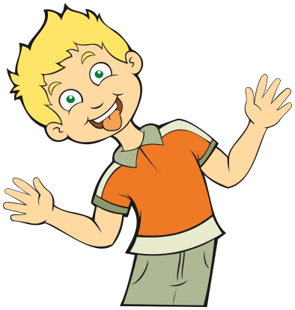
Hi, Jordan.
- Last weekend, I went to ______________________________.
- I went there with ________________________________.
- My favorite ride was ________________________________ .
- But I forgot to ride ________________________________.
- I promise myself to ride ___________________ next time.
- It was a great fun!
Hey, _____________________.
- Where did you go last weekend?
- Who did you go with?
- What is your favorite ride?
- Is there any ride you forgot to take?
- Which ride are you going to take next time?
- How was your trip?

